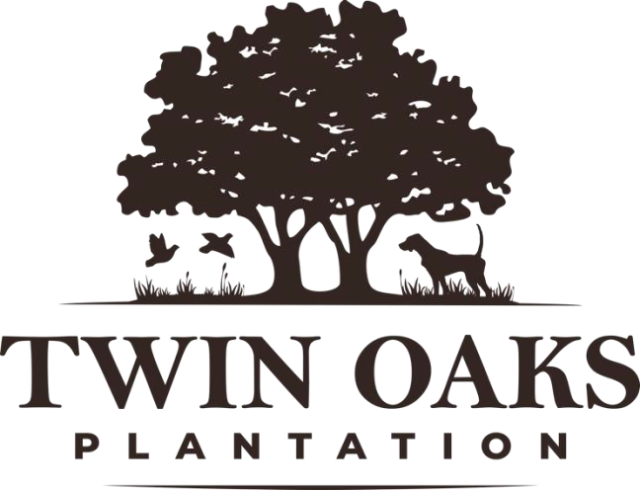

Twin Oaks Plantation is a fully commercial plantation located in Midway, AL.
Full Time Position: Hunting Guide/Plantation Technician

Qualifications:
- Experience on tractors/heavy equipment is preferred or must be willing to learn.
- Must be punctual and self-motivated.
- Must be capable of intense physical labor.
- Understanding of basic wildlife management practices or willing to learn.
- Prior knowledge of hunting dogs preferred or willing to learn.
- Prior experience guiding hunts preferred.

Job Summary:
Applicants will have the opportunity to be a part of the day-to-day operation of a fully commercial quail plantation. This position will provide plenty of hands-on experience with various wildlife/habitat management techniques, as well as opportunities to guide quail, deer, and turkey hunts. This full-time position requires a dedicated hard-working individual. Hours vary seasonally but will include some weekend work. Pay is hourly and based on prior experience.

Job Responsibilities:
  - General care and upkeep of dogs/ kennels
  - Assisting with dog training/conditioning
  - Implementing wildlife management practices put in place by manager.
  - General property maintenance.
  - Planting, Fertilization, and herbicide application
  - General maintenance of equipment.

Please send all resumes to: Manager: Michael Kennedy
(334)524-3781
twinoakshuntingal@gmail.com

