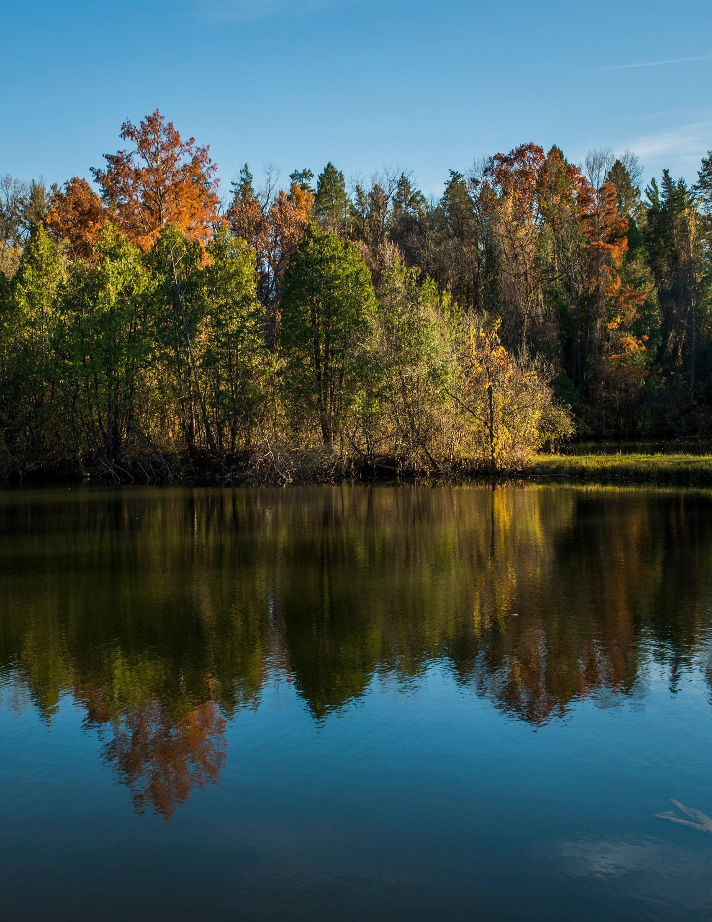


POSITION PROFILE

Guide and Habitat Specialist
Max McGraw Wildlife Foundation
Dundee, Illinois

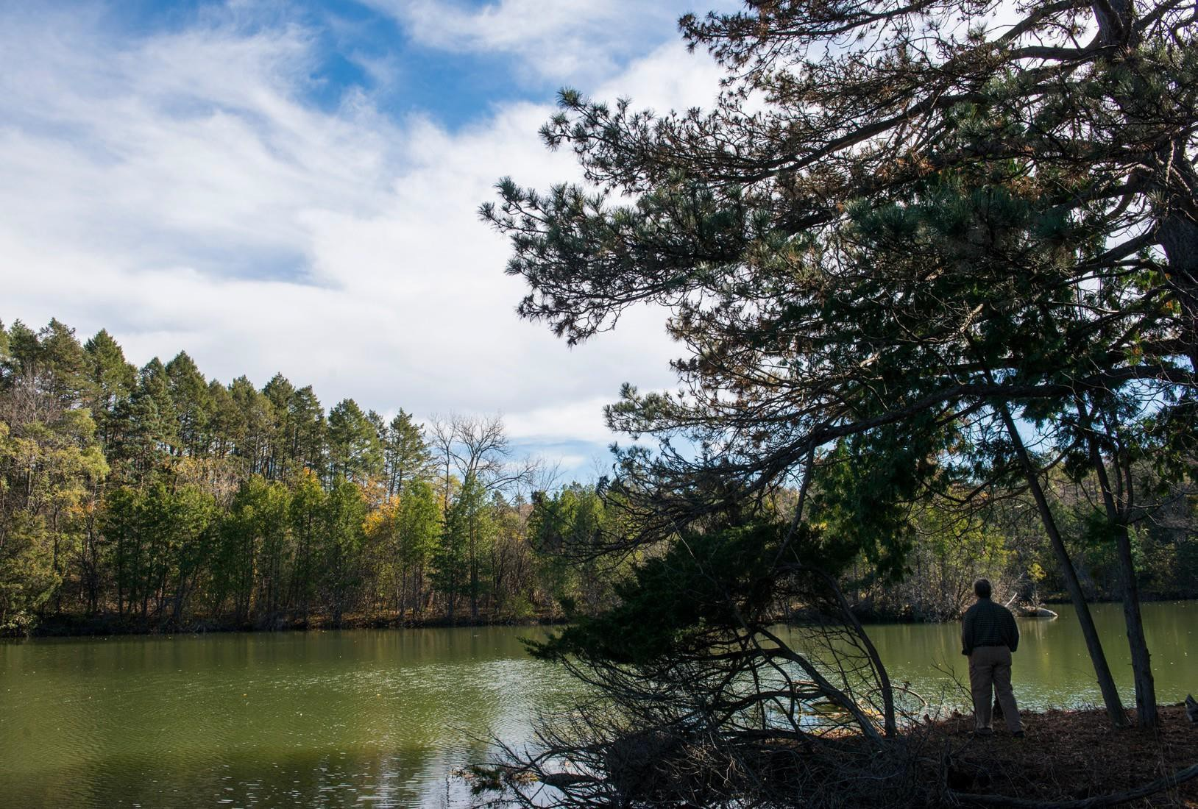
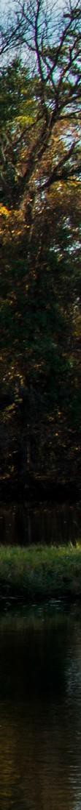
ABOUT MAX MCGRAW WILDLIFE FOUNDATION

For over 60 years the Max McGraw Wildlife Foundation (McGraw) has been the entrepreneurial thought leader in conservation and destination for people who enjoy have a strong connection to conservation, nature and the outdoors. The Foundation is headquartered near Chicago, on 1,250 acres in Dundee, Illinois — a verdant landscape encompassing dozens of lakes and ponds, wetlands, prairie, and mature woodlands, as well as abundant native flora and fauna. McGraw is a great place to unwind and be yourself.
The mission of Max McGraw Wildlife Foundation is to drive innovation and entrepreneurial thought in conservation. In their own words, McGraw enacts this vision through three main drivers:

We connect research and recreation, technology and tradition, classrooms and capitals. Our independence gives us the freedom to ask hard questions, uncover facts and build coalitions to promote the most efficient actions to sustain habitats, and humanity, for generations to come.
We bring together disparate groups and individuals to take on challenging issues and develop concrete plans to address them. Whether it is a policy-focused white paper detailing needed
reforms in existing programs or a multimillion-dollar film calling attention to the plight of North America’s prairie wetlands, McGraw makes the connections that drive new ideas in conservation.
We foster the careers of wildlife scientists and
researchers by conducting our own research and collaborating with other institutions. Our Urban Coyote Project is the longest-running study of the
interactions between coyotes and humans. Other research has pioneered the use of drones in wildlife population surveys, explained how raccoons have expanded their range, and demonstrated
the impact of feral cats on bird populations. Our work in fisheries has created breakthroughs in the rearing and stocking of game fish, lake management, and the emerging field of aquaponics.

Guide and Habitat Specialist
Max McGraw Wildlife Foundation 2

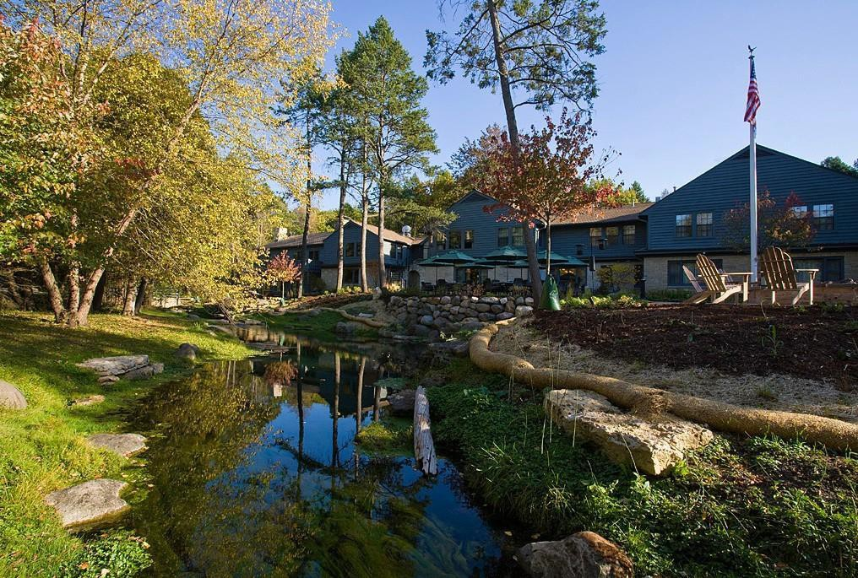
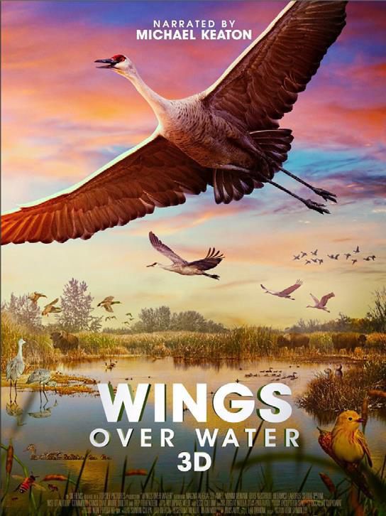
Through its renowned Conservation Leaders for Tomorrow (CLfT) program, McGraw has advanced the careers of nearly 3,000 college students and professionals in natural resources management. CLfT teaches participants about the North American model of wildlife conservation and the role that legal, ethical hunting plays in modern wildlife management.
McGraw is also an outdoor recreation and education facility, where thousands of children, adults and families have learned about the outdoors and conservation and have made memories to last a lifetime.

For more information on the Max McGraw Wildlife Foundation please visit their website at www.mcgraw.org.

Guide and Habitat Specialist
Max McGraw Wildlife Foundation 3

THE OPPORTUNITY
The Guide and Habitat Specialist will be an integral member of the McGraw Outdoor Recreation and Habitat team. Primary responsibilities include, but are not limited to, guiding upland hunts, guiding clay target shoots, assisting with kennel operations including dog training and handling, and overall habitat maintenance and stewardship. The individual will also assist in leading group shooting events and general maintenance.

The Guide & Habitat Specialist will serve as a team-player at McGraw, participating in an organizational culture that is collaborative and agreeable while enhancing the capabilities of the outdoor team, ultimately
positioning the organization for continued success.
Key responsibilities of the Guide & Habitat Specialist include, but are not limited to:

Principle Responsibilities & Position Purpose
- Member Services/ Guiding
  - Learn, understand, and execute all McGraw procedures and safety for hunting parties and clay target shooting parties.
  - Learn, understand, and execute the Range Master duties for the clay target center and archery/air gun ranges.
  - Provide excellent customer service and exceed members’ expectations.
  - Capable of and willing to work weekends, evenings and holidays as needed.
  - Willing and capable of working in other departments if needed and assisting the outdoor education team.
- Maintenance Service
  - Basic equipment maintenance and repair.
  - General building and structure maintenance.
  - Hunting blind/stand maintenance and care.
  - Grounds maintenance including mowing, weed control and trimming.
  - Assist with daily dog care/training, kennel sanitation and member services provided at the kennel.
- Land Management
  - Large and small scale brush cutting and trimming.
  - Planting, seeding and general care of wide variety of habitat and plants.
  - Food plot and hunting cover planting and maintenance.
  - Weed control through chemical application and prescribed burning.
- Position directly reports to the Director of Outdoor Recreation and Habitat.
- Other duties as assigned.

Guide and Habitat Specialist
Max McGraw Wildlife Foundation 4

SUPPORTIVE FUNCTIONS
In addition to performance of the essential functions, this position may be required to perform a combination of the following supportive functions, with the percentage of time performing each function to be solely determined by the supervisor based upon the particular requirements of the Foundation.
  - Attend mandatory meetings and McGraw staff meetings.
  - General Computer skills i.e. - Word, Excel, and Google Workspace
  - Assist other departments as needed.
  - Assists with outdoor education programs as assigned or required.

EXAMPLE OF DUTIES
Average percentage of time managing the duties of the Farm and Habitat Specialist.

30- Land and habitat management and invasive plant control
30- Member services and guiding
30- Maintenance service
10- Other duties as assigned

PHYSICAL REQUIREMENTS
Frequency Key: Never – 0 hours; Rare – up to 1 hour; Occasional – 1-3 hours; Frequent – 3-6 hours; Constant 6-8 hours

Sitting – Occasional Walking – Constant Climbing Stairs – Occasional Standing – Constant
Crouching/Bending/Stooping – Frequent Reaching – Frequent
Grasping – Frequent Pushing/Pulling – Occasional
Near Vision – Frequent Far Vision – Constant Hearing – Constant Talking – Constant Smell – Rare
Taste – Rare
Lifting/Carrying (# lbs.) – Frequent – up to 50+ lbs. Travel – Rare

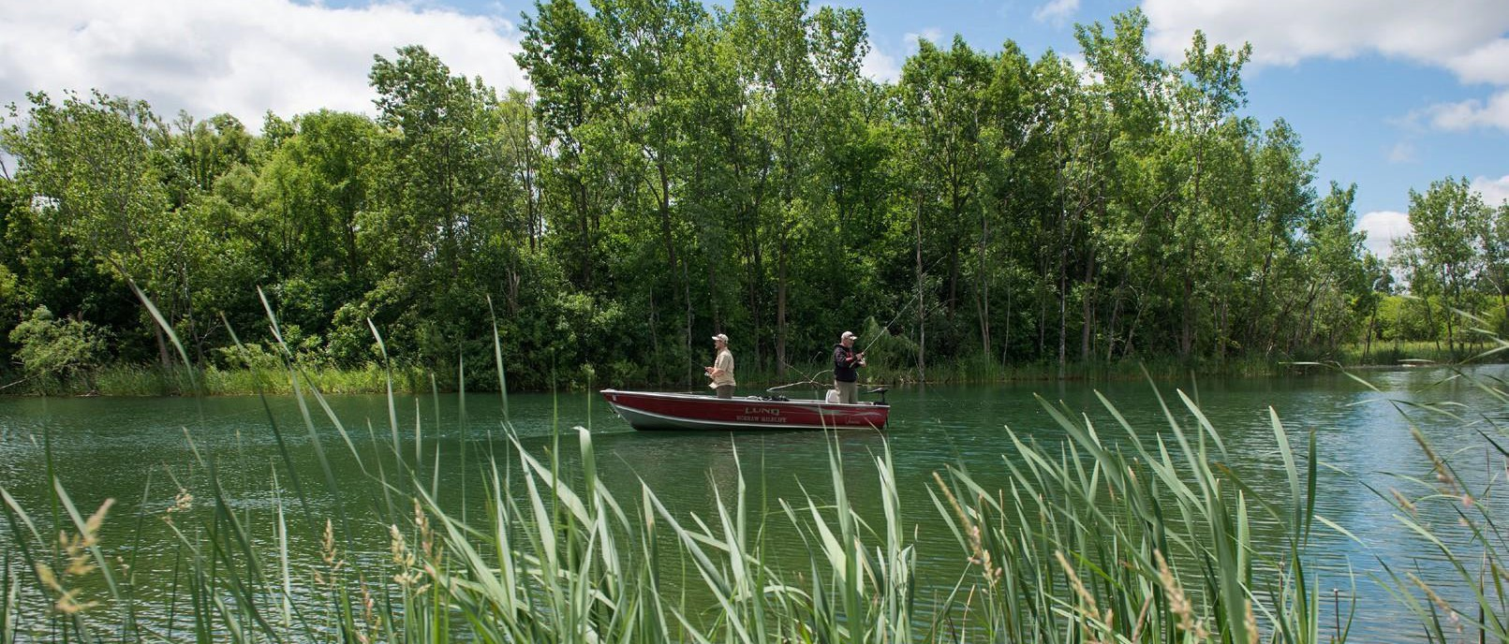

OTHER DUTIES
Assimilate into the McGraw culture through understanding, supporting and participating in all elements of pride and care in your job. Demonstrate working knowledge of the hospitality industry service standards. Regular attendance in conformance with the standards, which may be established by McGraw from time to time, is essential to the successful performance of this position. Due to the cyclical nature of the hospitality industry, employees may be required to work varying schedules to reflect the business needs of McGraw.

SAFETY REQUIREMENTS
OSHA laws require the use of Personal Protective Equipment (PPE) when performing work duties that have the potential of risk to your health or safety.

Guide and Habitat Specialist
Max McGraw Wildlife Foundation 5

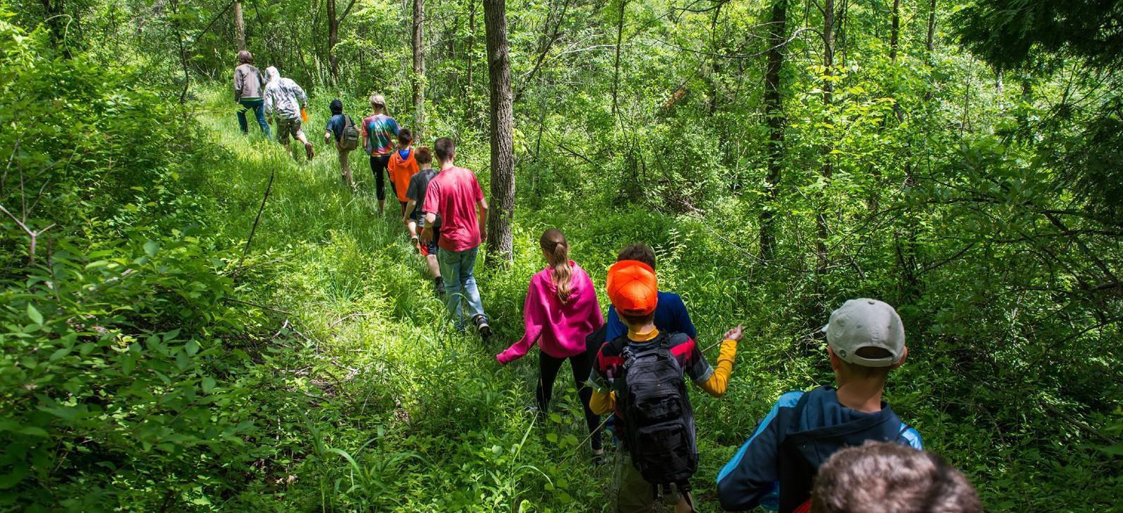
CANDIDATE PROFILE
While it is understood that no candidate will offer every desired skill, quality and characteristic, the following offers a detailed, aspirational view of the ideal candidate profile:

SPECIFIC JOB KNOWLEDGE, SKILL AND ABILITY
Hours: +/-40 hours per week. There are many occasions when overtime is required.
The individual must possess the following knowledge, skills and abilities and be able to explain and demonstrate that he or she can perform the essential functions of the job, with or without reasonable accommodation.

- Ability to effectively communicate verbally in English.
- Ability to effectively deal with internal and external customers, some of whom will require high levels of patience, tact, and diplomacy to defuse anger and collect accurate information.
- Ability to read English language sufficient to ascertain information presented.
- Ability to effectively explain all aspects of shooting sports safety and recognize unsafe actions.
- Gun safety and practical experience are desirable.
- Ability to work independently.
- Personable and able to relate to people of all ages and skill levels.
- Flexibility with respect to work hours and job assignments.
- Excellent work ethic, dependable, prompt, and loyal.
- Ability to work outside in all weather conditions.
- Carpentry, electrical, mechanical and plumbing skills are a plus.
- Desire to work cooperatively with or within other departments.

EDUCATION
High School diploma, College degree preferred. Background in agricultural habitat practices and active participation in shooting sports, fishing and dog training.

LICENSES OR CERTIFICATES
Valid Driver’s License, Hunters Safety Education Certificate, Valid Firearms Owners Identification Card (F.O.I.D.) or ability to obtain the card. CPR Certification and/or First Aid Certification Preferred. Private Chemical Applicators License, Burn Certification preferred.

GROOMING
All team members must maintain a neat, clean and well-groomed appearance. Employees are expected to be prepared and dressed appropriately based on their job responsibilities and duties. Employees must abide by the dress code while on the McGraw property.

Upon employment, all employees are required to fully comply with McGraw rules and regulations for the safe and efficient operation of the facilities. Employees who violate the rules and regulations will be subjected to disciplinary action, up to and including termination of employment.

Guide and Habitat Specialist
Max McGraw Wildlife Foundation 6

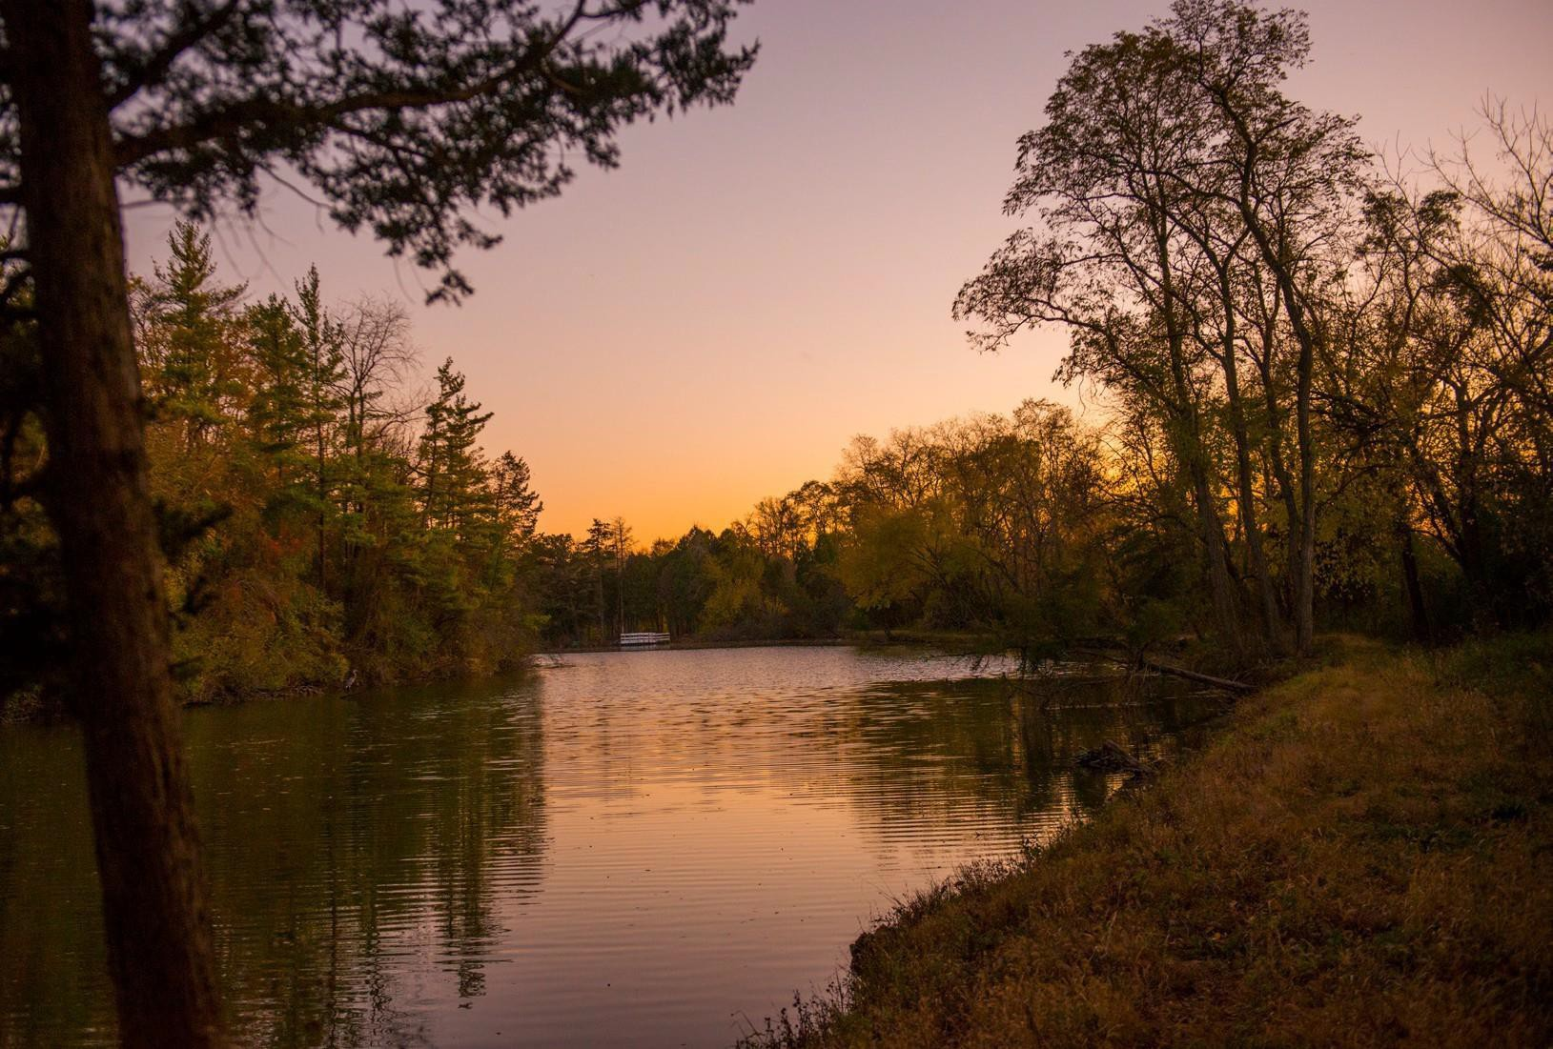
A CONNECTION TO THE MISSION & CULTURE
This guide will:
- Bring a passion for conservation with a clear commitment to maximizing McGraw’s impact.
- Have a strong solutions-oriented approach and “get to yes” attitude with a willingness and ability to be hands on and wear many hats.
- Be able to develop a powerful sense of shared purpose in others and motivate them to engage the opportunities and challenges ahead to support the foundation's development.
- Embrace and contribute to a mission-driven culture; be energized by the opportunity to join and add to a high-performing yet relaxed professional environment that encourages work-life balance.
- Be an individual of unquestioned integrity, ethics, and values — someone who always displays good judgement and can be trusted without reservation.

COMPENSATION
The budgeted salary for this position is between $55,000-60,000 per year, commensurate with background and experience. McGraw provides comprehensive insurance benefits including health, dental, and vision, a retirement savings plan, generous time off, and professional development.

LOCATION
This is an in-person role, with an expectation that the Guide & Habitat Specialist will be present at McGraw’s beautiful headquarters located in Dundee five days per week.
The culture is one that encourages employees to take advantage of the stunning 1,250-acre campus. Team members can often be found fishing, walking, and otherwise recreating during lunch breaks and on designated employee recreation days.

Guide and Habitat Specialist
Max McGraw Wildlife Foundation 7

CONTACT
To express interest in this role, please submit your resume and cover letter to Phil Dietrich at pdietrich@mcgraw.org. All inquiries and discussions will be considered strictly confidential.

Guide and Habitat Specialist
Max McGraw Wildlife Foundation 8

